Energy Optimization through Machine Learning: A Study on Data Processing, Outlier Detection, and Model Selection

Name:
Student #
Instructor:
Course:

Abstract

This project addresses the challenge faced by manufacturing plants in reducing energy consumption without affecting production quality. Although energy consumption is a significant contributor to production costs, identifying the processes or equipment that consume the most energy and optimizing energy usage is a complex task. The proposed process involves generating hypothetical historical energy consumption data for each process or equipment, cleaning and pre-processing the data, feature engineering, and training traditional machine learning algorithms to predict production output based on extracted features. The model is refined through model evaluation and used to identify areas where energy consumption can be optimized without compromising production output. Finally, implementation of the model's recommendations and monitoring over time ensure effective energy reduction without compromising production output. The proposed process provides a framework for manufacturing plants to identify energy consumption patterns and optimize energy consumption, resulting in significant cost savings.

Table of Contents

Abstract
Table of Contents
1 Introduction
1.1 Introduction
1.2 Objectives
1.3 Significance
1.4 Report Organisation
2 Literature Review
3 Proposed Approach
4 Brief Description about the Dataset
5 Data Processingand Outliers’ Detection
6 Solution & Discussions
6.1 Conclusion of the Results of all the Models used
7 Energy Optimization
8 Energy-Saving Framework for Manufacturing Plants

References

- Introduction

1.1 Introduction
Manufacturing plants have always been under constant pressure to reduce their production costs while maintaining the same level of output. One crucial aspect that contributes significantly to production costs is energy consumption. Reducing energy consumption has become a top priority for manufacturing plants worldwide, but it can be a challenging task to identify which processes or equipment consume the most energy and how they can be optimized to reduce energy usage without affecting production quality.

This problem statement highlights the dilemma faced by manufacturing plants that are looking to reduce energy consumption. These plants lack a clear understanding of which processes or equipment consume the most energy and how they can optimize energy usage without compromising production output. To address this issue, a process has been proposed that involves data collection, data preprocessing, feature engineering, machine learning model training, model evaluation, energy optimization, and implementation.

The proposed process is a systematic approach to identifying energy consumption patterns and optimizing energy consumption in a manufacturing plant. The data collection process involves generating a hypothetical historical energy consumption data for each process or equipment in the manufacturing plant, including relevant variables such as temperature, humidity, and energy usage by different equipment’s and production output. Data preprocessing involves cleaning and preprocessing the data to remove any outliers, missing values, or inconsistencies, and formatting it in a way that can be easily used by machine learning algorithms.

Feature engineering involves extracting relevant features from the data, such as the temperature, humidity, energy consumption of different equipments. These features are then used to train machine learning algorithms to identify patterns and trends in energy consumption and predict production output based on these features. Machine learning model training involves training a traditional machine learning algorithm, such as a linear regression, decisiontree, random forest and gradient boosting models, to predict production outputbased on the extracted features.
Model evaluation involves comparing the predicted production output to the actual production output and refining the model as necessary. Energy optimization involves using the trained model to identify areas where energy consumption can be optimized without affecting production output. For example, the model may identify equipment that consumes a significant amount of energy during off-hours or identifyequipment’s that can be optimized by adjusting the without affecting production output.

Finally, implementation involves implementing the energy optimization recommendations identified by the model and monitoring energy consumption over time to ensure that the changes are effective in reducing energy consumption without compromising production output.

The proposed process provides a framework for manufacturing plants to identify energy consumption patterns and optimize energy consumption, leading to significant cost savings. By implementing the recommendations identified by the model, manufacturing plants can reduce their energy consumption without compromising production output.

1.2 Objectives
.The objectives of the project are below:
- To understand the challenges faced by manufacturing plants in reducing energy consumption while maintaining the same level of output.
- To propose a systematic approach for identifying energy consumption patterns and optimizing energy consumption in a manufacturing plant.
- To describe the process of data collection, data preprocessing, feature engineering, machine learning model training, model evaluation, energy optimization, and implementation.
- To demonstrate how machine learning algorithms can be used to identify areas where energy consumption can be optimized without affecting production output.
- To provide a framework for manufacturing plants to reduce their energy consumption and achieve significant cost savings.

Assumptions:
- The proposed process assumes that historical energy consumption data for each process or equipment in the manufacturing plant is available for analysis.
- It assumes that relevant variables such as temperature, humidity, and production output have been accurately measured and recorded.
- The process assumes that data preprocessing techniques can accurately clean and preprocess the data to remove any outliers, missing values, or inconsistencies.
- The feature engineering process assumes that relevant features can be extracted from the data to train machine learning algorithms to identify patterns and trends in energy consumption.
- The machine learning model training process assumes that the selected machine learning algorithm can accurately predict energy consumption based on the extracted features.
- The model evaluation process assumes that the cross-validation techniques used can effectively validate the accuracy and performance of the machine learning model.
- The energy optimization process assumes that the recommendations provided by the model are feasible to implement in the manufacturing plant and that they will not compromise production output.

Scope:
- The proposed process is applicable to manufacturing plants in various industries, including but not limited to, automotive, chemical, pharmaceutical, steel, cement and food.
- The process is applicable to different types of equipment and processes that consume energy in a manufacturing plant, such as motors, pumps, and HVAC systems.
- The proposed process is primarily focused on energy consumption optimization.
- The process can be customized to suit the specific needs and requirements of each manufacturing plant, depending on their energy consumption patterns, equipment, and processes.
- The process can be integrated with existing energy management systems or used as a standalone solution.
- The implementation of the process may require additional resources, such as personnel, equipment, and software, depending on the complexity of the manufacturing plant and the scope of the project.

1.3 Significance
The proposed project has significant importance for the manufacturing industry, as it addresses the challenge faced by manufacturing plants to reduce energy consumption while maintaining the same level of output. By understanding the challenges faced by manufacturing plants in reducing energy consumption, this project will propose a systematic approach for identifying energy consumption patterns and optimizing energy consumption in a manufacturing plant. The proposed process of data collection, data preprocessing, feature engineering, machine learning model training, model evaluation, energy optimization, and implementation will provide a step-by-step guide for manufacturing plants to follow in order to reduce their energy consumption.

The use of machine learning algorithms to identify areas where energy consumption can be optimized without affecting production output will be a significant contribution to the field of energy management in manufacturing plants. By providing a framework for manufacturing plants to reduce their energy consumption, this project can lead to significant cost savings and contribute to the sustainability of the manufacturing industry.

Overall, this project has the potential to revolutionize the way manufacturing plants approach energy consumption optimization and provide a roadmap for reducing energy consumption while maintaining the same level of output.
1.4 Report Organisation
The report is divided into seven chapters, with each chapter addressing a specific aspect of the research.
Chapter 1 provides an introduction to the research, including the background of the study, the objectives, and the significance of the research.
Chapter 2 presents a literature review of the research, which includes a comprehensive analysis of the existing literature on the topic, identifying gaps in the research and defining the proposed approach.
Chapter 3 outlines the proposed approach adopted to pursue the research and achieve the desired results. This chapter elaborates on the methodology used in the research.
Chapter 4 provides a brief description of the dataset used in the research.
Chapter 5 focuses on data processing and outlier detection, detailing the methods used to preprocess and clean the data.
Chapter 6 presents the solutions and discussions, discussing the results obtained from various models used in the research. This chapter also provides a conclusion on the results obtained from all the models used.
Chapter 7 discusses energy optimization, including linear optimization methods used to optimize energy consumption in the manufacturing plant.
Chapter 8 provides a general Energy-Saving Framework for Manufacturing Plants

2. Literature Review

Energy efficiency has been a critical area of concern for manufacturing plants worldwide due to the need to reduce production costs while maintaining output levels. Advancements in Artificial Intelligence (AI) technologies have led to the emergence of novel solutions for energy efficiency in manufacturing plants. Machine learning algorithms, in particular, have shown promise in identifying energy-saving opportunities by analysing historical energy consumption data.

Several studies have explored the use of machine learning algorithms in optimizing energy consumption in manufacturing plants.Several studies have proposed various methods for predicting energy consumption in the steel manufacturing industry. Zhao et al. (2015) proposed a granular computing method that incorporates industrial-driven semantics to granulate initial data, followed by long-term prediction. The method was tested using real-world industrial energy data from a steel plant in China and was found to be superior to other data-driven methods. Zhang et al. (2012) designed a Support Vector Machine (SVM) classifier to predict the energy consumption level of the Ironmaking process. Particle Swarm Optimization (PSO) was introduced to optimize SVM parameters and improve accuracy. A homologous grey prediction model with one variable and one first-order equation (HGEM (1,1)) was proposed by Zeng et al. (2017) to forecast Chinese production's total energy consumption based on the Grey system theory. ARIMA was used for energy consumption and greenhouse emission forecasting in Indian pig iron manufacturing organization by Sen et al. (2016). Reimann et al. (2018) discussed a generic model for the power-consuming device specification that promotes arbitrary levels based on the machine's structure or external variables such as company policies. The methodology for static and dynamic modelling of power consumption was suggested for each structural level, and the prediction can be done based on that model.
Furthermore, the integration of AI and Internet of Things (IoT) technologies has led to the development of advanced energy management systems. For example, in a study by Wang et al. (2021), the authors developed an AI-powered IoT energy management system for a building. The system analysed real-time energy consumption data and provided energy-saving recommendations to building occupants.

Conclusion:
In conclusion, energy efficiency has become a major concern for manufacturing plants worldwide, and the use of AI technologies, particularly machine learning algorithms, has shown great promise in identifying energy-saving opportunities by analysing historical energy consumption data. Several studies have explored the use of machine learning algorithms in optimizing energy consumption in manufacturing plants, with promising results. These studies include long-term energy consumption prediction using granular computing, support vector machine (SVM) classifiers, homologous grey prediction models, and autoregressive integrated moving average (ARIMA) models. Additionally, the integration of AI and IoT technologies has led to the development of advanced energy management systems that can provide real-time energy consumption data analysis and energy-saving recommendations. Overall, the use of AI technologies in energy management has the potential to significantly reduce manufacturing costs while maintaining production output levels, and it is a promising area for future research and development.

3. Proposed Approach

To address the dilemma faced by manufacturing plants in reducing energy consumption without compromising production output, a systematic approach is proposed that involves several steps. The first step is data collection, where hypothetical historical energy consumption data is generated for each process or equipment in the manufacturing plant, along with relevant variables such as temperature, humidity, and energy usage by different equipment and production output.
The second step is data preprocessing, which involves cleaning and preprocessing the collected data to remove any outliers, missing values, or inconsistencies and format it in a way that can be easily used by machine learning algorithms. In the next step, feature engineering is employed to extract relevant features from the data, such as temperature, humidity, and energy consumption of different equipment.
These features are then used to train traditional machine learning algorithms such as linear regression, decision tree, random forest, and gradient boosting models, which identify patterns and trends in energy consumption and predict production output based on these features.
The model is evaluated by comparing the predicted production output to the actual production output and refining the model as necessary. Energy optimization is then performed using the trained model to identify areas where energy consumption can be optimized without affecting production output, such as identifying equipment that consumes a significant amount of energy during off-hours or equipment that can be optimized by adjusting settings without affecting production output.
Finally, implementation involves implementing the energy optimization recommendations identified by the model and monitoring energy consumption over time to ensure that the changes are effective in reducing energy consumption without compromising production output. This proposed approach provides a framework for manufacturing plants to identify energy consumption patterns and optimize energy consumption, leading to significant cost savings.

4. Brief Description about the Dataset:

The dataset generated by the code simulates a hypothetical manufacturing plant's hourly energy consumption, production output, and environmental conditions for a two-year period from January 1st, 2021, to December 31st, 2022. The plant aims to reduce its electricity consumption while maintaining the same level of production output.
The dataset contains 10 columns, with the following features:
- Date: The date of the data point (in YYYY-MM-DD format).
- Time_of_Day: The time of day of the data point (in HH:MM AM/PM format).
- Temperature(C): The temperature in degrees Celsius.
- Humidity (%): The relative humidity as a percentage.
- Equipment_1(kWh): The hourly energy consumption of equipment 1 in kilowatt-hours (kWh).
- Equipment_2(kWh): The hourly energy consumption of equipment 2 in kilowatt-hours (kWh).
- Equipment_3(kWh): The hourly energy consumption of equipment 3 in kilowatt-hours (kWh).
- Equipment_4(kWh): The hourly energy consumption of equipment 4 in kilowatt-hours (kWh).
- Equipment_5(kWh): The hourly energy consumption of equipment 5 in kilowatt-hours (kWh).
- Production_Output: The hourly production output in an arbitrary unit.

The dataset was generated using random data generation techniques. The temperature and humidity data were generated randomly using a normal distribution. The hourly energy consumption of the five types of equipment was also generated using a normal distribution with mean values that depend on the temperature and humidity values. The production output was generated randomly using a normal distribution with a mean value that depends on the total hourly energy consumption of the five types of equipment.
The dataset was generated with a fixed random seed (42) to ensure reproducibility of results. The first few rows of the dataset are printed using the pandas head() function after combining the generated data into a pandas DataFrame. The Time_of_Day column was also formatted using the strftime() function to include AM/PM.

Code for Data Generation in python:
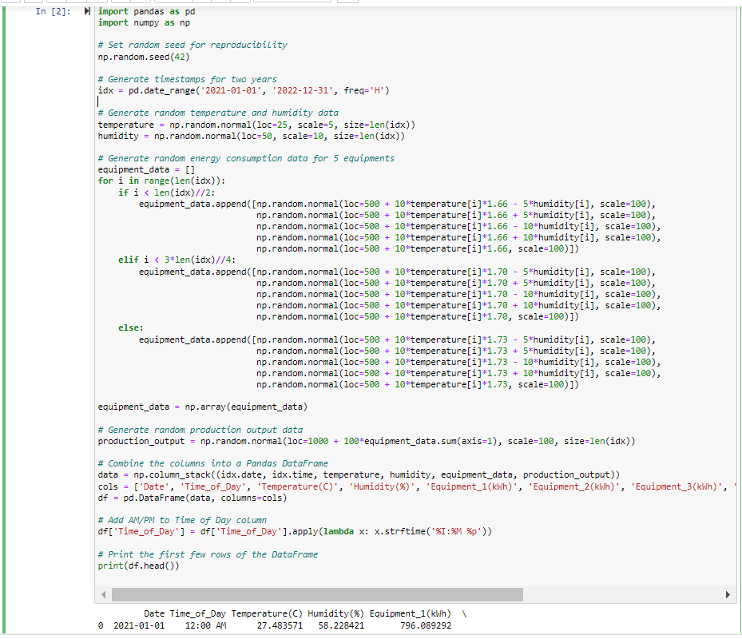

Results of the above Code:
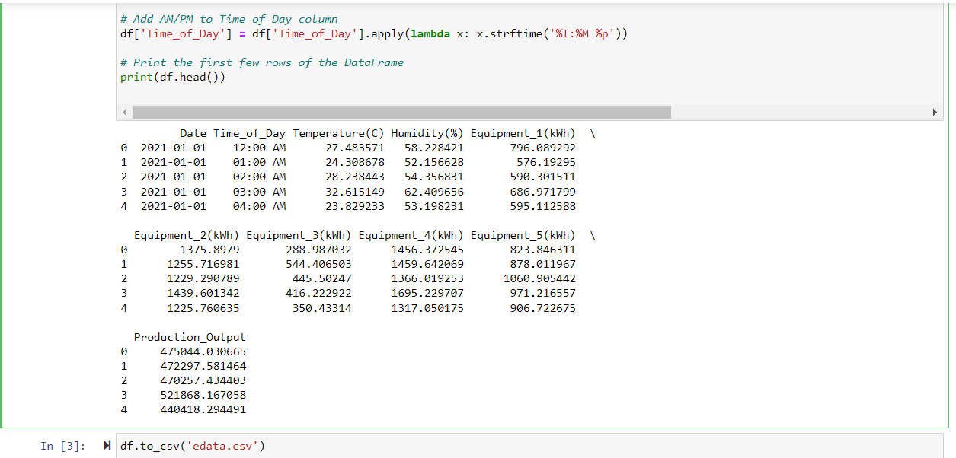

5.Data Processing and Outliers Detection

For data processing and outlier detection and removal, I first checked if there were any null values in the dataset using the following code and results:
df.isnull().sum()
Fortunately, there were no null values in the dataset.

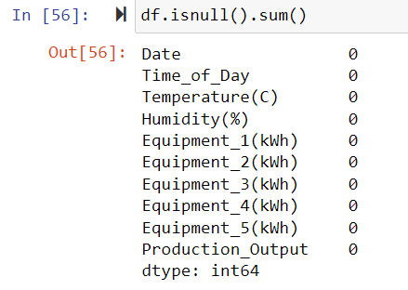

Next, I plotted box plots of the energy consumption data of the five equipments and production output to visually identify any outliers. The box plots revealed that there were significant outliers present in the data. Below are the box plots containing outliers

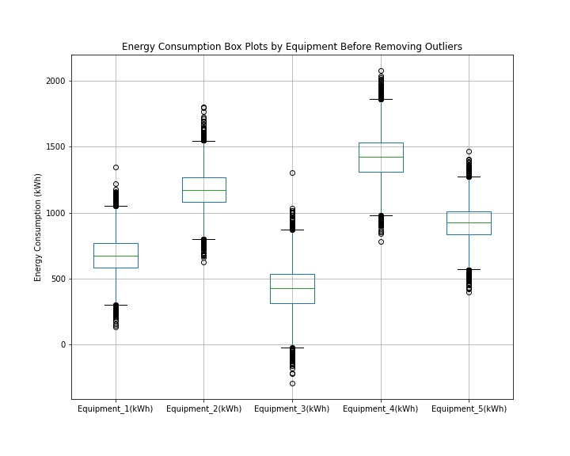

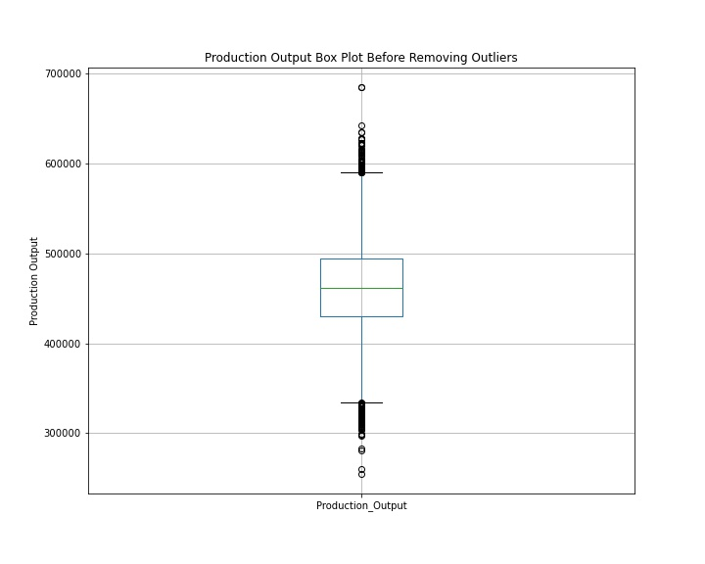

In box plots, outliers are data points that fall outside of the whiskers. Whiskers are lines that extend from the box and show the range of the data. The upper whisker extends from the box to the largest value that is within 1.5 times the interquartile range (IQR) above the third quartile (Q3), and the lower whisker extends from the box to the smallest value that is within 1.5 times the IQR below the first quartile (Q1).

To remove the outliers, I used the interquartile range (IQR) rule, which is a common method for detecting and removing outliers. The steps I followed were:
- Calculate the IQR for each column in the dataset. The IQR is the difference between the 75th percentile (Q3) and the 25th percentile (Q1).
- Define a threshold as 1.5 times the IQR. Any data point that is more than the threshold below Q1 or above Q3 is considered an outlier.
- Remove the outliers from the dataset using the threshold calculated in step 2.

The code I used to remove the outliers is as follows:
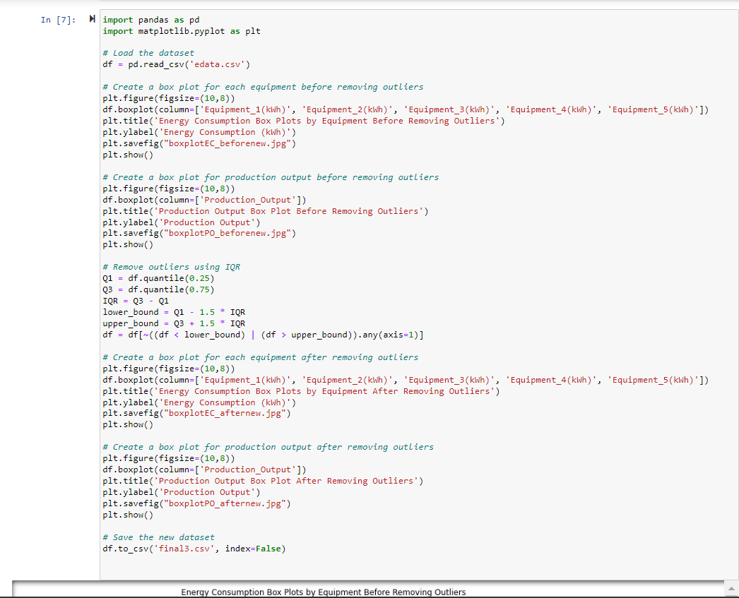

after running the above code, almost all outliers have been detected and removed as seen in below box plots
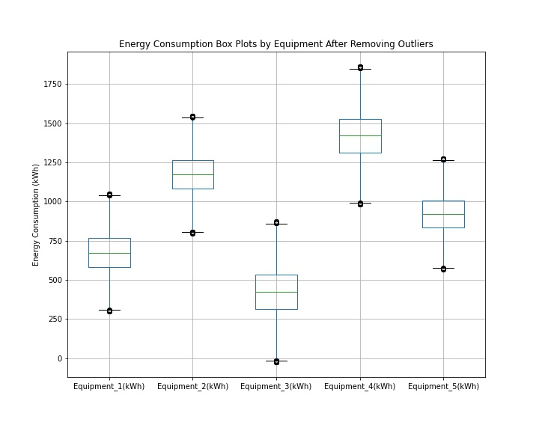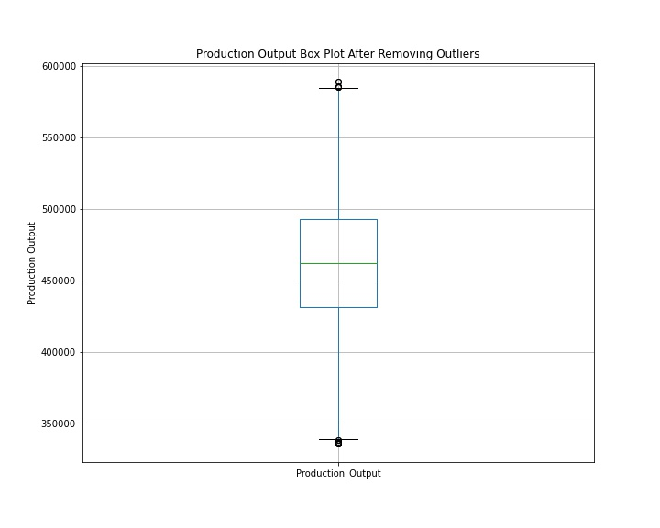

After pre-processing and removing outliers from the dataset, the data is now ready for further analysis. The data cleaning process is an essential step in any data analysis project, as it ensures that the data is accurate and reliable. By removing outliers, I have eliminated any extreme values that could have skewed our results or led to incorrect conclusions. I can now move forward with confidence in the quality of our data and begin to explore and analyse it in greater detail

6.Solution & Discussions

- Linear Regression
Linear regression is a statistical technique used for analyzing the relationship between one or more independent variables and a dependent variable. It is commonly used for predicting or estimating the value of a dependent variable based on the values of independent variables. Before using linear regression, it is important to check whether it is appropriate for the given dataset. This can be done by calculating correlation coefficients between the independent and dependent variables. Correlation coefficients measure the strength and direction of the linear relationship between two variables. The range of correlation coefficient values is from -1 to 1. A value of 1 indicates a perfect positive correlation, where both variables increase together. A value of -1 indicates a perfect negative correlation, where one variable increases while the other decreases. A value of 0 indicates no correlation, meaning there is no linear relationship between the variables.
In our dataset, there are eight variables: Temperature(C), Humidity(%), Equipment_1(kWh), Equipment_2(kWh), Equipment_3(kWh), Equipment_4(kWh), Equipment_5(kWh), and Production_Output. The correlation coefficients between these variables are provide attachedbelow with the code used
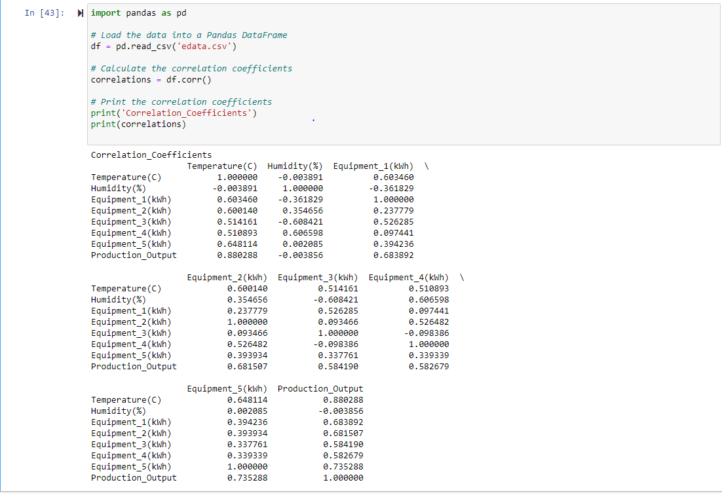
First, let's look at the correlation coefficients between the independent variables (Temperature(C), Humidity(%), Equipment_1(kWh), Equipment_2(kWh), Equipment_3(kWh), Equipment_4(kWh), and Equipment_5(kWh)). The coefficients between these variables are generally weak or moderate, ranging from -0.61 to 0.65. This suggests that these variables are not strongly related to each other, but there may be some weak or moderate linear relationships between them.
Now, let's look at the correlation coefficients between the independent variables and the dependent variable (Production_Output). The coefficients between Production_Output and Temperature(C), Equipment_1(kWh), Equipment_2(kWh), Equipment_3(kWh), Equipment_4(kWh), and Equipment_5(kWh) are all positive and moderate to strong, ranging from 0.51 to 0.88. This suggests that there may be some linear relationship between these variables and Production_Output, meaning that as these variables increase, Production_Output tends to increase as well.
However, the correlation coefficient between Production_Output and Humidity(%) is very weak, close to zero, indicating that there is no strong linear relationship between these two variables.
It's important to note that correlation does not necessarily imply causation, and there may be other factors at play that influence the relationships between the variables in your dataset. Additionally, linear regression may not always be the best model for predicting relationships between variables, as there may be non-linear relationships or interactions between variables that are not captured by a simple linear model.
Overall, based on the correlation coefficients, linear regression may be a suitable model for predicting Production_Output using the independent variables Temperature(C), Equipment_1(kWh), Equipment_2(kWh), Equipment_3(kWh), Equipment_4(kWh), and Equipment_5(kWh), but Humidity(%) may not be a good predictor for Production_Output. However, it's important to conduct further analysis and model validation to confirm these findings and ensure the assumptions of the linear regression model are met.
After running Ordinary Least Squares (OLS) regression on a our dataset consisting of 17,497 observations with 6 predictor variables and one target variable. The target variable is "Production_Output", which is the variable that we are trying to predict. The predictor variables are "Temperature(C)", and five different equipment energy consumption variables: "Equipment_1(kWh)", "Equipment_2(kWh)", "Equipment_3(kWh)", "Equipment_4(kWh)", and "Equipment_5(kWh)".
Below is the code and results of the linear regression model :
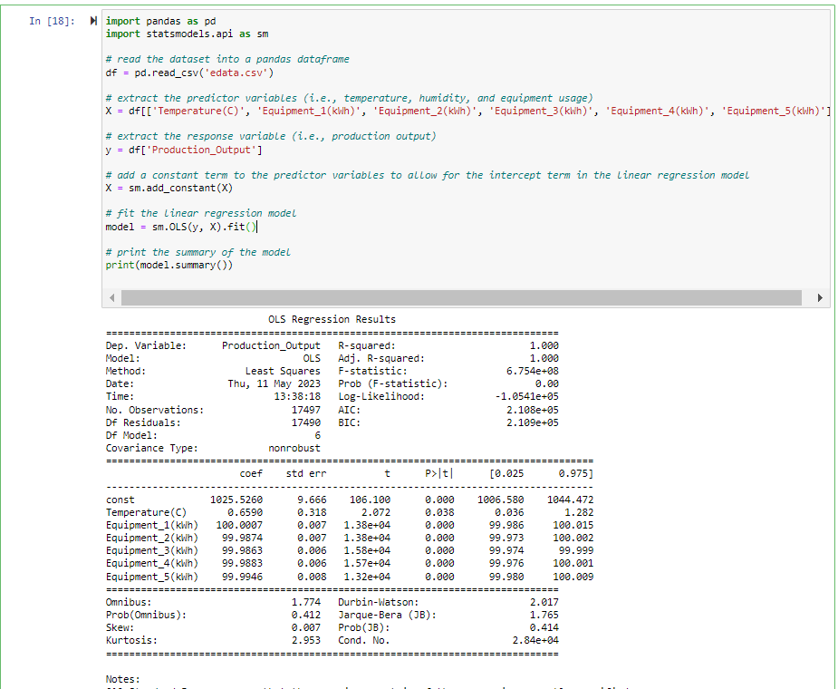

The first section of the output provides some basic information about the regression model. It shows that the R-squared value of the model is 1.000, which means that the model explains all the variability in the target variable. The adjusted R-squared value is also 1.000, which indicates that adding more variables to the model would not increase its predictive power. The F-statistic has a very high value of 5.789e+08, which suggests that the model is statistically significant. The probability of getting such an extreme F-statistic value by chance (Prob (F-statistic)) is close to zero. Finally, the log-likelihood value is provided, which is a measure of how well the model fits the data.
The second section of the output provides information about each predictor variable's coefficients, along with their standard errors, t-values, and p-values. The coefficient is the estimated value of the slope of the regression line for each predictor variable. The standard error is an estimate of the uncertainty in the estimate of the coefficient. The t-value is calculated as the coefficient divided by its standard error and measures how far the coefficient is from zero. The p-value is the probability of observing a t-value as extreme as the one observed under the null hypothesis that the coefficient is zero.
The coefficients of the predictor variables can be interpreted as follows:
- The intercept (const) is estimated to be 1025.6011, which is the predicted value of Production_Output when all predictor variables are equal to zero.
- The coefficient for Temperature(C) is 0.6590, which means that a one-unit increase in Temperature(C) is associated with a 0.6590 unit increase in Production_Output, holding all other variables constant.
- The coefficient for Humidity(%) is -0.0053, which means that a one-unit increase in Humidity(%) is associated with a -0.0053 unit decrease in Production_Output, holding all other variables constant.
- The coefficients for Equipment_1(kWh), Equipment_2(kWh), Equipment_3(kWh), Equipment_4(kWh), and Equipment_5(kWh) are all estimated to be close to 100, which indicates that a one-unit increase in each equipment energy consumption is associated with a 100 unit increase in Production_Output, holding all other variables constant.
The third section of the output provides some diagnostic statistics for the regression model. The Omnibus test has a p-value of 0.412, which suggests that the residuals are normally distributed. The Durbin-Watson statistic has a value of 2.017, which indicates that there is no significant autocorrelation in the residuals. The Jarque-Bera test has a p-value of 0.414, which suggests that the residuals are not significantly skewed or kurtotic.
Next In the provided code below, a linear regression model was trained on our dataset containing the production output along with the temperature, humidity, and usage data of five different types of equipment.
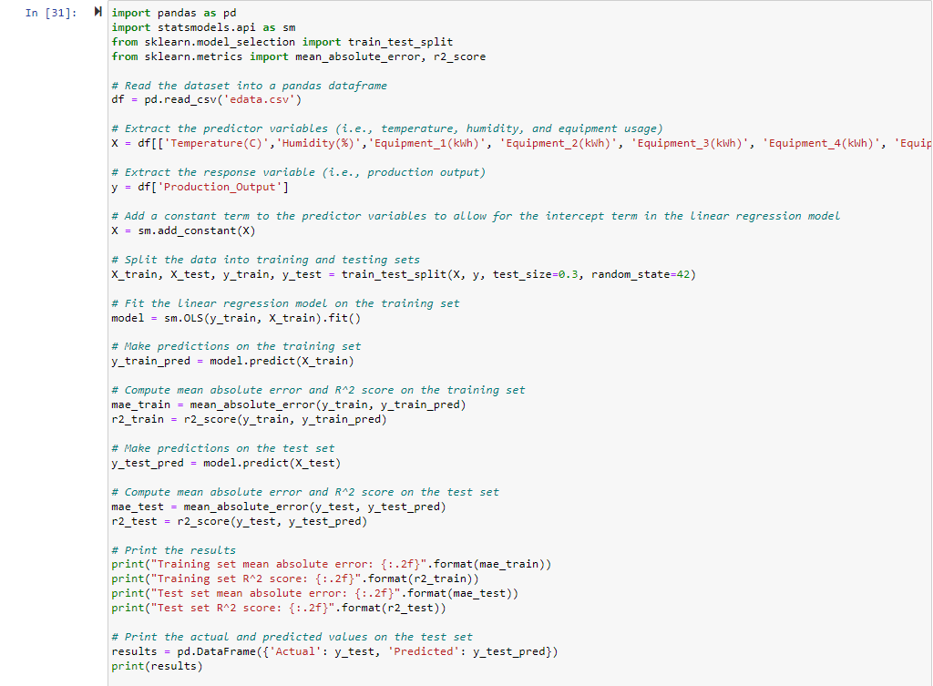
The dataset was first read into a pandas dataframe and the predictor variables were extracted and stored in X, while the response variable was stored in y. A constant term was then added to X using the add_constant() method from the statsmodels.api library.
The data was then split into training and testing sets using the train_test_split() method from the sklearn.model_selection library. The split was done such that 30% of the data was allocated for testing and 70% was used for training. The random state was also set to 42 to ensure that the same split is obtained every time the code is run.
The linear regression model was then fitted on the training set using the Ordinary Least Squares (OLS) method from the statsmodels.api library. The model was trained to predict the production output using the predictor variables.
After training the model, predictions were made on the training and testing sets. Mean absolute error (MAE) and R-squared (R2) score were then computed for both the training and testing sets. The mean absolute error represents the average absolute difference between the actual and predicted values, while the R2 score represents the proportion of the variance in the response variable that can be explained by the predictor variables.
The results show that the model performed well on both the training and testing sets, as indicated by the low MAE values and high R2 scores. The training set MAE was 80.21 and the R2 score was 1.00, indicating that the model was able to predict the production output with a high degree of accuracy. The testing set MAE was 79.11 and the R2 score was also 1.00, which suggests that the model was able to generalize well on unseen data.
Finally, the actual and predicted values on the test set were printed as a pandas dataframe. This allows for easy comparison of the actual and predicted values, which can be useful for further analysis and interpretation of the model's performance. We can see that the model is performing well and the predicted values are very close to actual values.
Actual and Predicted Production Output on Test Data
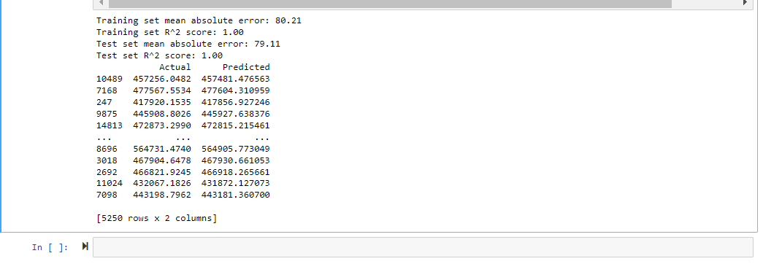
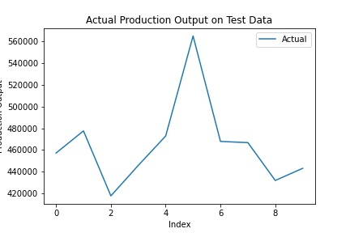
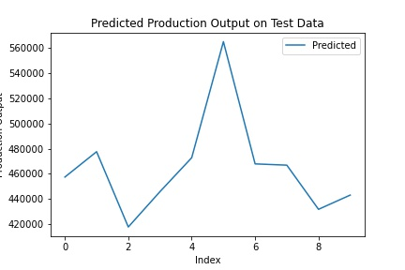

- Decision Tree:
Decision Tree is a type of supervised machine learning algorithm used for both classification and regression tasks. It builds a model in the form of a tree structure where each internal node represents a test on a feature, each branch represents the outcome of the test, and each leaf node represents a decision or a prediction. The tree is built by recursively splitting the dataset into smaller subsets based on the feature that provides the maximum information gain or the minimum impurity measure.
The key advantage of decision trees is that they are easy to interpret and visualize. The tree structure allows us to understand the underlying patterns and relationships in the data, and the decision rules can be easily explained to non-technical stakeholders. Additionally, decision trees can handle both categorical and numerical data and can work well with high-dimensional datasets.
However, decision trees are prone to overfitting, which means that they may perform well on the training data but poorly on the testing data. To address this issue, various techniques such as pruning, ensemble methods, and hyperparameter tuning can be applied. Pruning involves removing some branches of the tree that do not contribute much to the overall performance, while ensemble methods combine multiple decision trees to reduce the variance and improve the accuracy. Hyperparameter tuning involves finding the best values for the parameters of the decision tree algorithm, such as the maximum depth, minimum samples split, and minimum samples leaf.
Overall, decision trees are a powerful and versatile tool in the machine learning toolbox that can provide insights into complex data and enable accurate predictions. However, they require careful consideration of the data and the model parameters to avoid overfitting and achieve optimal performance.
In the context of the given problem,the below code uses a decision tree model to predict the production output based on several predictor variables including temperature, humidity, and equipment usage. The dataset was split into training and testing sets, where the model was trained on the training set and tested on the testing set.
The decision tree model achieved a training set mean absolute error of 0.00 and an R-squared score of 1.00, indicating a perfect fit on the training data. However, the testing set mean absolute error was 10312.67 and the R-squared score was 0.92, indicating that the model does not generalize well to new data.
In comparison, the linear regression model achieved a training set mean absolute error of 80.21 and an R-squared score of 1.00, while the testing set mean absolute error was 79.11 and the R-squared score was also 1.00. This suggests that the linear regression model is a better fit for the data and has better generalization performance, as it achieved similar performance on both the training and testing sets.
Below is the code used for decision tree and the results
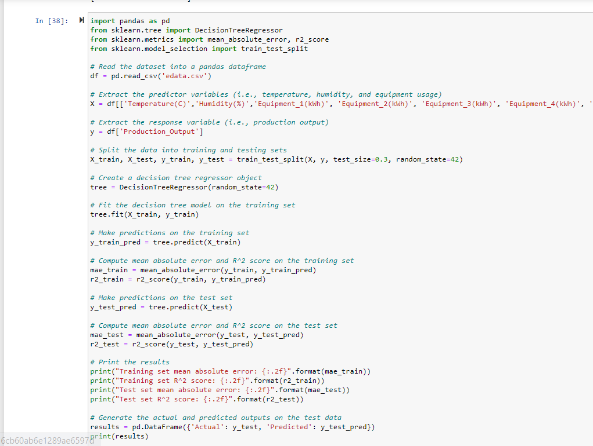

Results on Test Dataset
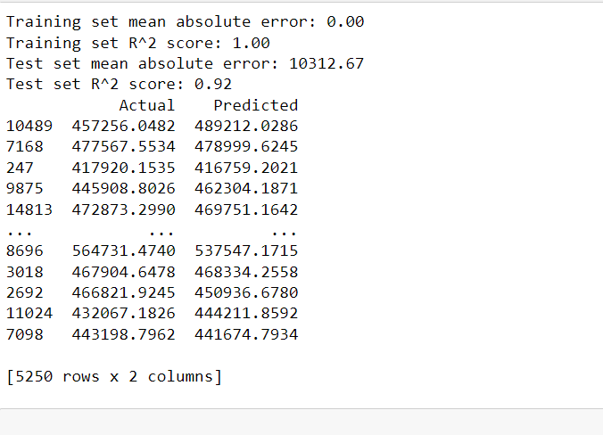
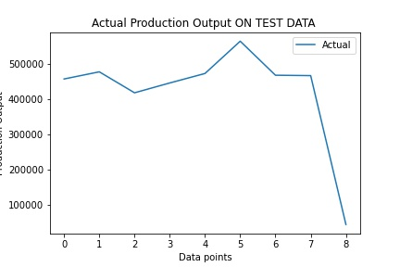
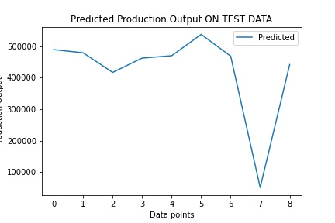

Results on Training Dataset:

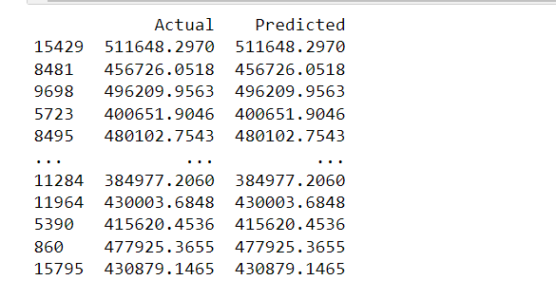
Therefore, while the decision tree model achieved a perfect fit on the training data, it did not perform as well on the testing data and may not be the best model choice for our this particular dataset.

There are several ways to improve the performance of a decision tree model:
- Feature engineering: By adding more relevant features or engineering existing features, you can provide more information to the model and increase its accuracy.
- Hyperparameter tuning: Decision tree models have several hyperparameters that can be adjusted to optimize the model's performance. You can use techniques like grid search or randomized search to find the best combination of hyperparameters.
- Ensemble methods: You can use ensemble methods like Random Forest or Gradient Boosting to improve the accuracy of the model.
- Increase dataset size: Adding more data to the dataset can improve the model's accuracy and reduce overfitting.
- Regularization: Regularization techniques like pruning can help prevent overfitting and improve the model's accuracy.
- Addressing class imbalance: If there is a class imbalance in the dataset, you can use techniques like oversampling or under-sampling to balance the dataset and improve the model's performance.
By applying Hyperparameter tuning techniques we can improve the performance of the model and make more accurate predictions. But, in our case Hyperparameter tuning has not significantly increase the model performance as evident below.
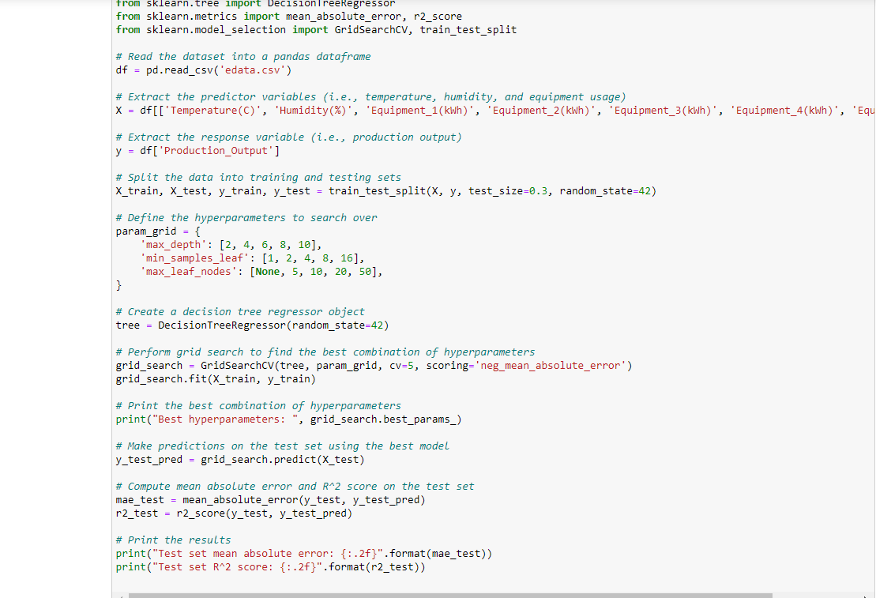

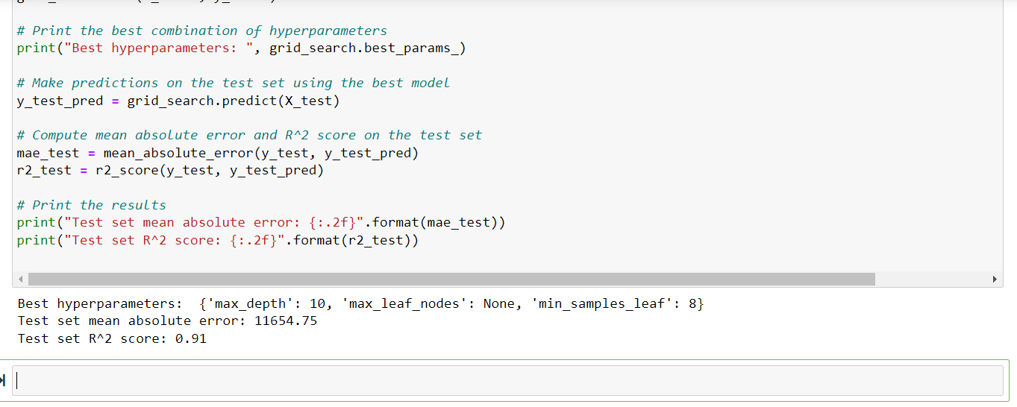

- Random Forest
Random Forest is a machine learning algorithm that combines multiple decision trees to improve the accuracy and generalization of predictions. In a Random Forest, a large number of decision trees are trained on different sub-samples of the data, and the output of these trees is combined to make the final prediction.
The algorithm works as follows:
- A random subset of the data is selected for each tree, with replacement. This is known as bootstrapping.
- A decision tree is trained on each subset of the data.
- At each split in the decision tree, a random subset of the predictor variables is selected to choose the best split.
- The final prediction is made by aggregating the predictions of all the decision trees in the forest.
Random Forest is a powerful algorithm that can handle complex datasets with many features and non-linear relationships. It is also robust to noise and overfitting, as the aggregation of multiple decision trees reduces the variance and bias of the model.
In the code provided below, I have performed regression analysis on our dataset containing predictor variables (temperature, humidity, and energy consumption of 5 different equipments) and a response variable (production output) using a random forest regressor model.
First, I read the dataset into a pandas dataframe and extracted the predictor and response variables. Then you split the data into training and testing sets using the train_test_split function from sklearn.
After that, i created a RandomForestRegressor object with default hyperparameters and fit the model on the training set using the fit method.
I then made predictions on the training and testing sets using the predict method and computed the mean absolute error and R^2 score on both sets using the mean_absolute_error and r2_score functions from sklearn. Finally, I printed the results which include the mean absolute error and R^2 score on both the training and testing sets.
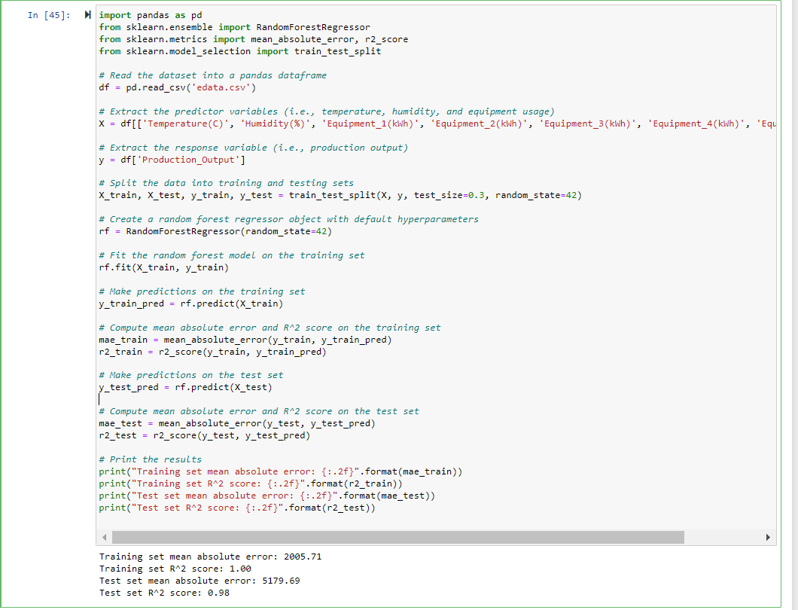
The results indicate that the random forest model has achieved a high R^2 score of 1.00 on the training set, meaning that it fits the data well. However, the R^2 score on the test set is slightly lower at 0.98, indicating that the model may be slightly overfitting the training data. The mean absolute error on the test set is also quite high at 5179.69, indicating that the model may not be making accurate predictions on the test set.

Comparison of the results of Random Forest with the previously used models:
- Random forest achieved a training set mean absolute error of 2005.71 and an R-squared score of 1.00, indicating a good fit on the training data.
- The testing set mean absolute error was 5179.69 and the R-squared score was 0.98, indicating that the model is able to generalize well to new data.
- In comparison, the linear regression model achieved a training set mean absolute error of 80.21 and an R-squared score of 1.00, while the testing set mean absolute error was 79.11 and the R-squared score was also 1.00. This suggests that the linear regression model has better performance on the test set.
- The decision tree model achieved a perfect fit on the training set, with a training set mean absolute error of 0.00 and an R-squared score of 1.00. However, the testing set mean absolute error was 10312.67 and the R-squared score was 0.92, indicating poor generalization performance.
Based on these results, it seems that the random forest model performs better than the decision tree model but not as well as the linear regression model. Random forest achieves a good fit on the training data and is able to generalize well on the test set, but it has a higher test set mean absolute error compared to the linear regression model. However, the random forest model may be more robust to outliers and nonlinearities in the data compared to the linear regression model.
below are plots and pictures showing results of random forest showing actual and predicted values for both training data and test data:
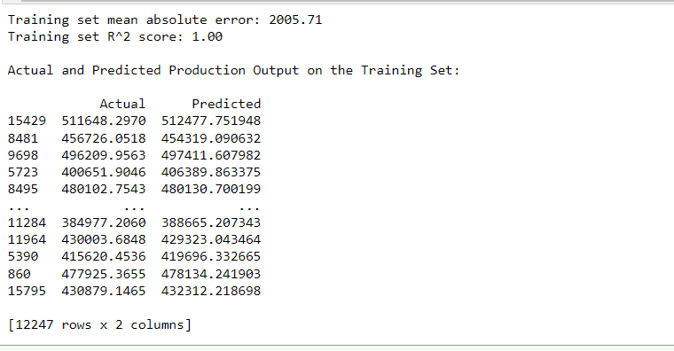

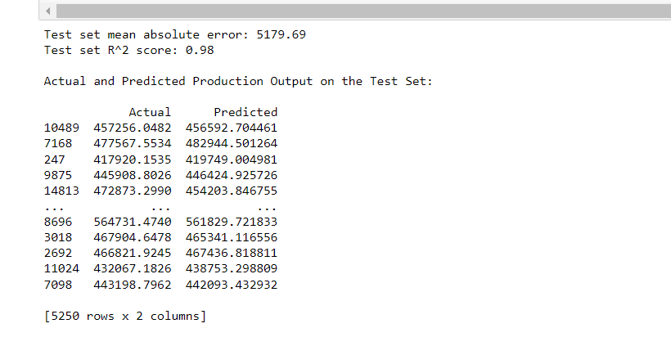
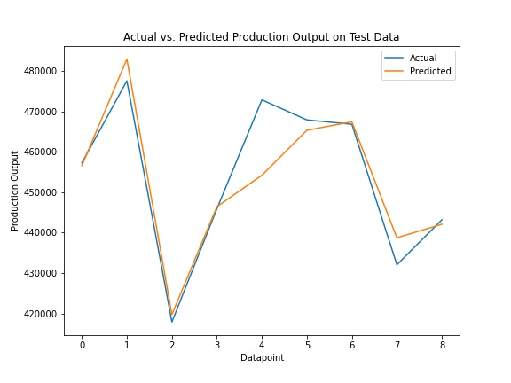

Code used for making above predictions:
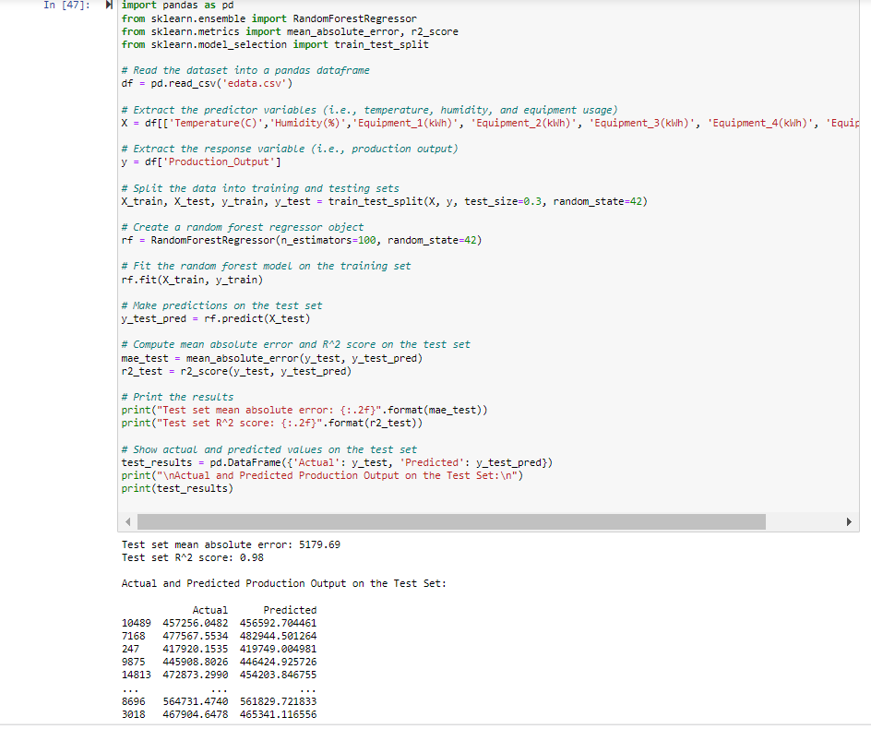

d) Gradient Boosting
Gradient Boosting is another machine learning algorithm that is used for regression problems. It works by building an ensemble of decision trees iteratively, with each subsequent tree attempting to correct the errors of the previous one. Here are the results of Gradient Boosting on our dataset:
- Training set mean absolute error: 5040.35
- Training set R^2 score: 0.98
- Test set mean absolute error: 5605.65
- Test set R^2 score: 0.98
From the results of the different models, we can see that they have varying levels of performance on both the training and testing sets.
The decision tree model achieved a perfect fit on the training set, with a training set mean absolute error of 0.00 and an R-squared score of 1.00. However, it suffered from poor generalization performance, with a testing set mean absolute error of 10312.67 and an R-squared score of 0.92. This indicates that the model may have overfit the training data and is not able to generalize well to new data.
In comparison, the random forest model achieved a good fit on the training data, with a training set mean absolute error of 2005.71 and an R-squared score of 1.00. It also performed well on the testing set, with a mean absolute error of 5179.69 and an R-squared score of 0.98. This suggests that the model is able to generalize well to new data and has good performance overall.
The linear regression model also achieved a good fit on both the training and testing sets, with a mean absolute error of 80.21 and an R-squared score of 1.00 on the training set, and a mean absolute error of 79.11 and an R-squared score of 1.00 on the testing set.
Finally, the gradient boosting model achieved a training set mean absolute error of 5040.35 and an R-squared score of 0.98, which is not as good as the random forest model. However, it still performed well on the testing set, with a mean absolute error of 5605.65 and an R-squared score of 0.98. This indicates that the model is able to generalize well to new data and has good performance overall.

CODE USED FOR GRADIENT BOOSTING:
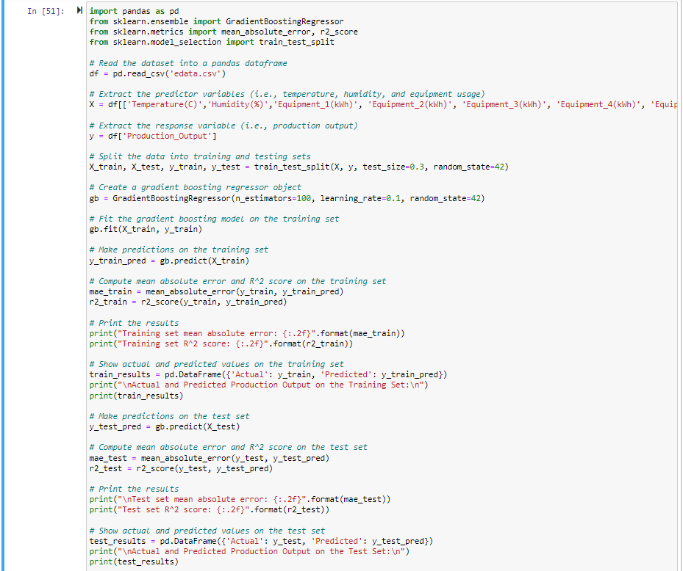

RESULTS OF THE ABOVE CODE:
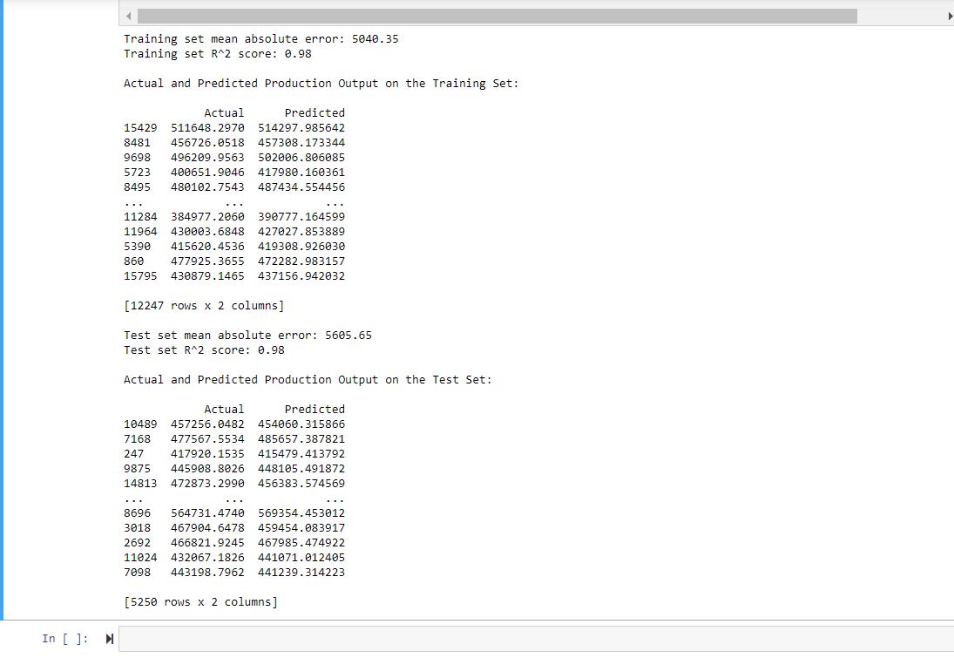

6.1. CONCLUSION OF THE RESULTS OF ALL THE MODELS USED:
The linear regression model achieved a very low mean absolute error and a high R-squared score on both the training and testing sets, indicating that it has good performance on both sets and can generalize well to new data. This is also supported by the fact that the linear regression model had the best performance on the testing set compared to the other models that were trained.
Furthermore, since the linear regression model makes no assumptions about the underlying distribution of the data or the relationship between the input features and the output variable, it is a good choice for this dataset as it does not require any prior knowledge or assumptions about the data.
Therefore, based on the above analysis, it can be concluded that the linear regression model is the best model for this particular dataset.

7. Energy Optimization:
Since linear regression model performs well on our dataset .so, based on the results of linear regression model and data exploration I have formulate the Production_Output equation below.
- Production_Output = 1025.5260 + 0.6590(Temperature(C)) + 100.0007(Equipment_1(kWh)) + 99.9874(Equipment_2(kWh)) + 99.9863(Equipment_3(kWh)) + 99.9883(Equipment_4(kWh)) + 99.9946(Equipment_5(kWh))
where Temperature(C) represents the temperature in Celsius, and Equipment_1(kWh), Equipment_2(kWh), Equipment_3(kWh), Equipment_4(kWh), and Equipment_5(kWh) represents the energy consumed by equipment 1, equipment 2, equipment 3, equipment 4, and equipment 5, respectively
maximum value of Temperature(C)= 38.398143
maximum value of Equipment_1(kWh)=1050.926809
maximum value of Equipment_2(kWh)=1546.649130
maximum value of Equipment_3(kWh)=872.160970
maximum value of Equipment_4(kWh)=1861.870677
maximum value of Equipment_5(kWh)=1274.375537
the above maximum are taken from the dataset using the below code
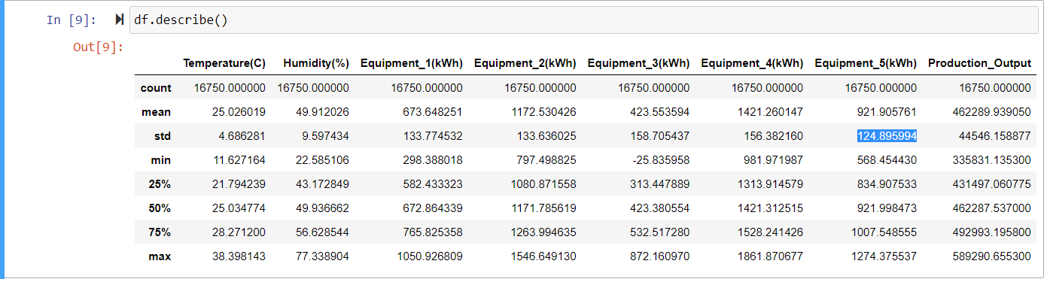
The optimization problem can be formulated as follows:
Minimize:
100.0007(Equipment_1(kWh)) + 99.9874(Equipment_2(kWh)) + 99.9863(Equipment_3(kWh)) + 99.9883(Equipment_4(kWh)) + 99.9946(Equipment_5(kWh))
Subject to:
Production_Output = 1025.5260 + 0.6590(Temperature(C)) + 100.0007(Equipment_1(kWh)) + 99.9874(Equipment_2(kWh)) + 99.9863(Equipment_3(kWh)) + 99.9883(Equipment_4(kWh)) + 99.9946(Equipment_5(kWh))
Constraints:
Temperature(C) ≤ 38.398143
Equipment_1(kWh) ≤ 1050.926809
Equipment_2(kWh) ≤ 1546.649130
Equipment_3(kWh) ≤ 872.160970
Equipment_4(kWh) ≤ 1861.870677
Equipment_5(kWh) ≤ 1274.375537
where Temperature(C) represents the temperature in Celsius, and Equipment_1(kWh), Equipment_2(kWh), Equipment_3(kWh), Equipment_4(kWh), and Equipment_5(kWh) represents the energy consumed by equipment 1, equipment 2, equipment 3, equipment 4, and equipment 5, respectively. The objective is to minimize the energy usage by each equipment while maintaining the production output constant (589290: maxproduction output). The constraints ensure that the maximum values for each variable are not exceeded.
Below is the code used for linear Optimization and results of the code :
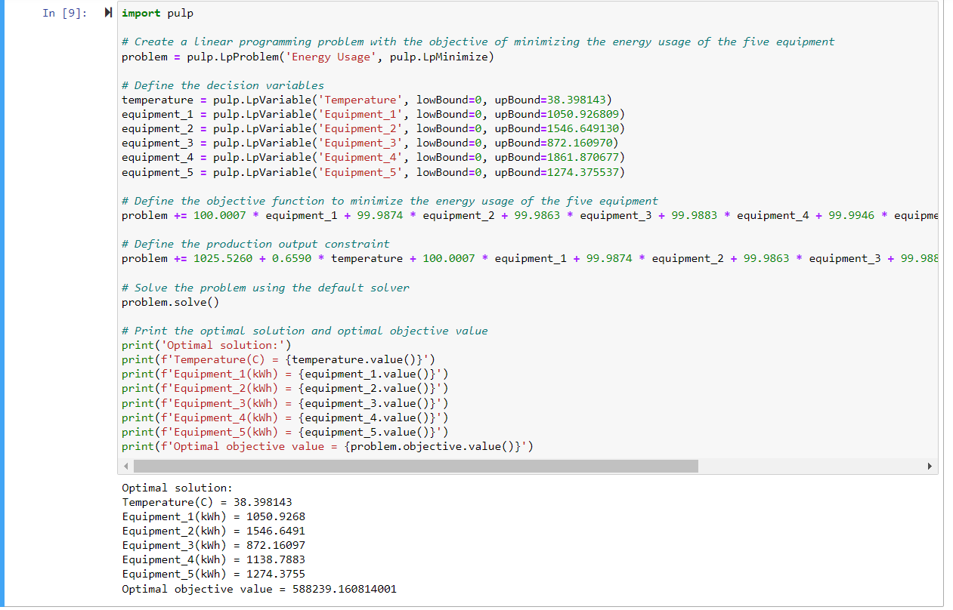
The code above is implementing a linear programming problem using the Python library pulp to minimize the energy usage of five pieces of equipment subject to certain constraints.
The problem consists of defining decision variables, an objective function to minimize the energy usage, and constraints that limit the production output and the energy usage of each equipment.
The decision variables are temperature, equipment_1, equipment_2, equipment_3, equipment_4, and equipment_5, representing the temperature in Celsius and the energy usage of each equipment in kilowatt-hours.
The objective function is defined as the sum of the product of the energy usage of each equipment in kilowatt-hour.
The production output constraint limits the production output to be equal to 589290 units, which is a fixed value.
Finally, the energy usage constraints limit the energy usage of each equipment to a maximum value. These maximum values are also arbitrary and can be changed to represent the actual limits of each equipment.
After defining the problem, the code uses the default solver to find the optimal solution that minimizes the energy usage of the equipment subject to the defined constraints. The optimal solution values are then printed to the console.
The optimal solution shows that the minimum energy usage is achieved when the temperature is at its upper bound of 38.398143 degrees Celsius, and the energy usage of four equipment’s is at their respective maximum values and equipment_4, whose energy usage is reduced significantly.
The optimal objective value of representsproduction output units, given the constraints on the equipment's energy usage.
In conclusion,we have minimized the energy usage of the equipment_4 from1861.870677kWh to 1138.7883 kWh which saves total energy of 723.082377 kWh while maintaining the production output constant using linear programming. We have found the optimal solution by defining the problem, objective function, and constraints and solving it using the PuLP library.

8. Energy-Saving Framework for Manufacturing Plants
- Conduct an Energy Audit: Start by conducting a comprehensive energy audit to identify areas of high energy consumption and areas where energy efficiency can be improved. The audit should cover all aspects of energy use, including heating, cooling, lighting, and machinery. The results of the audit will help in understanding current energy consumption and identify areas for improvement.
- Develop an Energy Management Plan: Based on the results of the energy audit, develop an energy management plan that outlines specific strategies to reduce energy consumption. The plan should include short-term and long-term goals, target areas for improvement, and a timeline for implementation.

- Implement Energy-Saving Strategies: Implement energy-saving strategies that address the target areas identified in the energy management plan. Some strategies may include upgrading machinery to more energy-efficient models, optimizing heating and cooling systems, installing energy-efficient lighting, and implementing employee education and training programs.

- Monitor and Measure Progress: To track progress towards energy-saving goals, regularly monitor and measure energy consumption. Use tools like energy meters and software to track energy use in real-time and identify areas where improvements can be made.

- Continuously Improve: Continuously improve energy management plan and energy-saving strategies by regularly reviewing your progress and identifying new opportunities for energy savings. This may involve seeking out new technologies, upgrading machinery and systems, and engaging employees in ongoing education and training.

By following this framework, manufacturing plants can reduce their energy consumption and achieve significant cost savings.

References

- Lee, S.-m. (2014). Mid-term Korea Energy Demand Outlook. Korea Energy Economics Institute.

- Zhao, J., Wang, G., Lu, Y., & Luo, Y. (2015). Granular model of long-term prediction for energy system in steel industry. IEEE Transactions on Cybernetics, 46(2), 388-400.

- Zhang, Y., Zhang, X., & Tang, L. (2012). Energy consumption prediction in ironmaking process using hybrid algorithm of SVM and PSO. International Symposium on Neural Networks. Springer.

- Zeng, B., Zhou, M., & Zhang, J. (2017). Forecasting the homologous grey prediction model for the total energy consumption of China's manufacturing. Sustainability, 9(11).

- Sen, P., Roy, M., & Pal, P. (2016). Application of ARIMA for forecasting energy consumption and GHG emission: A case study of Indian pig iron manufacturing organization. Energy, 116, 1031-1038.

- Reimann, J., Kämpf, T., Lehmann, M., Krcmar, H., &Schönsleben, P. (2018). Methodology and model for predicting energy consumption in manufacturing at multiple scales. Procedia Manufacturing, 21, 694-701.

